**Weather Station Documentation**

Contents

1. Introduction 2

1.1 Purpose 2

1.2 Scope 2

1.3 Revision History 2

2. Overview 3

2.1 Features: 3

2.2 Components: 3

2.3 System Architecture: 4

3. Hardware Specifications 5

3.1 Sensor Modules 5

3.2 Microcontroller/Processor 7

3.3 Power Supply 8

3.4 Communication Interfaces 8

3.5 Housing/Enclosure 9

4. Assembly Instructions 10

4.1 Step-by-step Electrical Assembly 10

4.2 Step-by-step Mechanical Assembly 13

4.3 Completion and Testing 16

4.3 Debugging and Tracing 16

5. Appendix 18

5.1 Schematics 18

5.2 Source Code 18

5.3 Contact Information 18

# 1. Introduction

1.1 Purpose

The purpose of this document is to provide comprehensive documentation for the Weather Station developed on Nov 2023 by DK Innovation Labs.

1.2 Scope

This documentation covers the hardware and software aspects of the weather station, including specifications, assembly instructions, operation guide, and safety considerations.

## 1.3 Revision History

Version 1.0 (11/2023): Initial release

# 2. Overview

## 2.1 Features:

* Solar-powered operation for sustainable and autonomous functionality
* Multi-sensor capabilities, providing real-time data on:
* Air Temperature
* Air Humidity
* Wind Speed
* Wind Direction
* Rain Sensor
* Soil Temperature (Up to 3 levels)
* Soil Humidity (Up to 3 levels)
* Soil Properties:
* Soil Electrical Conductivity (EC value)
* Soil Moisture
* PH Value
* Nitrogen Levels
* Phosphorus Levels
* Potassium Levels
* Enclosure door monitoring
* Battery and solar voltage monitoring

## 2.2 Components:

* Solar Panel
* Charge Controller
* Battery
* Microcontroller: - STm32F103C8T6
* Air Temperature and Humidity Sensor
* Soil Temperature and Humidity Sensors
* NPK Sensor
* Communication Module: - GSM SIM 800
* Housing/Enclosure

## 2.3 System Architecture:

The solar panel harnesses energy to charge the system's battery, managed by the charge controller. The battery, in turn, powers the Printed Circuit Board (PCB). Within the PCB, the microcontroller adeptly processes sensor data by employing communication protocols, namely USART and I2C. The culmination of this data is then transmitted via the GSM SIM800 module to interact with the Google Sheets API, facilitating the seamless updating of sensor data in real-time.

# 3. Hardware Specifications

## 3.1 Sensor Modules

The weather station incorporates a comprehensive array of sensor modules to capture diverse environmental parameters:

* **NPK Soil multiparameter sensor** (Soil Electrical Conductivity (EC value), Soil temperature, Soil Moisture, PH Value, Nitrogen Levels, Phosphorus Levels, Potassium Levels)
  + Interfacing (USART)

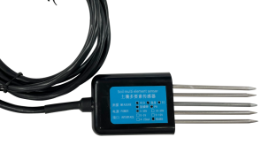

Figure 1 NPK 7 in 1 Soil Sensor with 5 Pins

* **SHT20 Sensor** (Air/Soil Temperature and Humidity)
  + Interfacing (I2C)

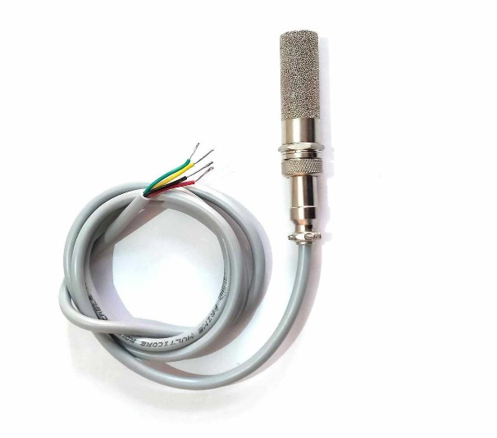

Figure 2 SHT10/20/30 Sensor

* **Wind Speed Sensor or Anemometer** (Wind Speed in m/sec.)
  + Under Progress, will be released in V2.0

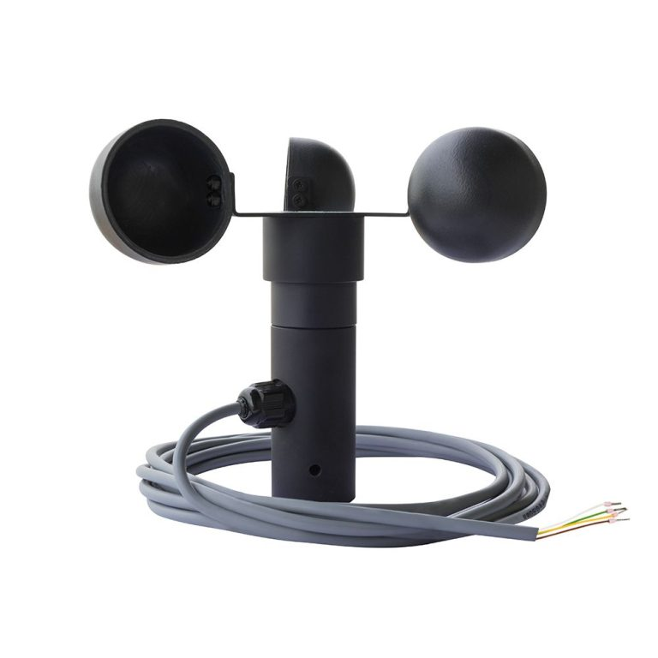

Figure 3 Anemometer

* **Wind Direction Sensor** (Range 0-360 Degree)
  + Under Progress, will be released in V2.0

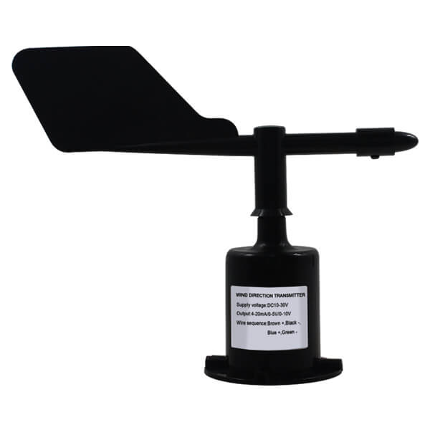

Figure 4 Wind Direction sensor

* **Rain Sensor** 
  + Under Progress, will be released in V3.0
* **Leaf Sensor** 
  + Under Progress, will be released in V3.0
* **UV Sensor** 
  + Under Progress, will be released in V3.0

## 3.2 Microcontroller/Processor

The central processing unit of the weather station is the Blue Pill microcontroller, but it could be replaced with any CortexM3 Board if needed.

**Microcontroller Model:** BluePill

**Processor**: STM32F103C8T6

Figure 5 BluePill

## 3.3 Power Supply

To sustain continuous operation, the weather station employs a robust power supply system:

* Solar Panel:
  + Peak Power: 10 W
  + Maximum Power Voltage: 17.5v
  + Maximum Power Current: 0.57A
  + Open Circuit Voltage: 21.5V
  + Short Circuit Current: 0.65A
* Charge Controller:
  + PWM
  + 12v/ 24v Auto Adapt.
  + 20 A
* Rechargeable Battery:
  + 12V
  + 2.3Ah
  + Lead Acid
* Regulator
  + Regulators in PCB to reduce voltage to 5, 4 and 3.3 volt.
    - 5 Volt for some Sensors
    - 4 Volt for GSM
    - 3.3 Volt for BluePill and some Sensors

## 3.4 Communication Interfaces

Efficient communication is facilitated through carefully selected interfaces:

* GSM Module: SIM800L GPRS
* Data Transmission: GSM SIM800 module used for real-time updates to a Google Sheets API

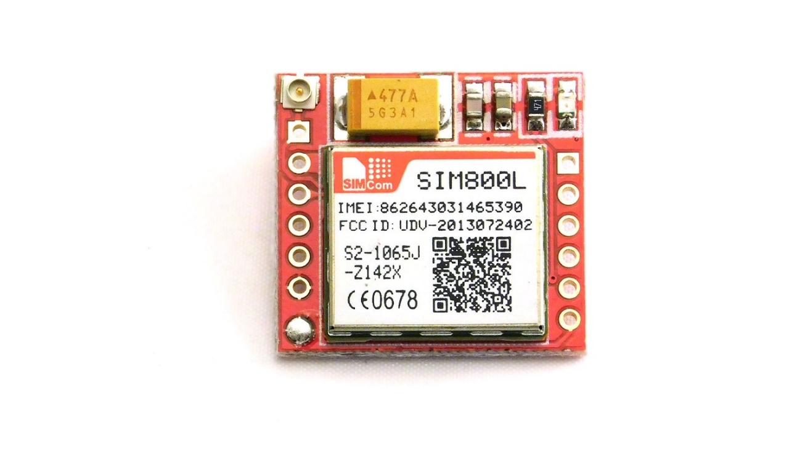

Figure 6 GSM

## 3.5 Housing/Enclosure

The weather station is securely housed within a waterproof box to safeguard its components from environmental elements:

**Enclosure Type:** Waterproof Box

**Material**: Plastic

**Dimensions:** 280*210*74mm

Figure 7 Waterproof Enclosure

# 4. Assembly Instructions

## 4.1 Step-by-step Electrical Assembly

All electrical components are connected internally of externally to a printed circuit board (PCB). There are two PCBs in this weather station.

1. Main PCB contain Microcontroller, GSM, sensor ports, LED indecators….etc.
2. Charge controller to mange the power of solar panel and charge the battery.

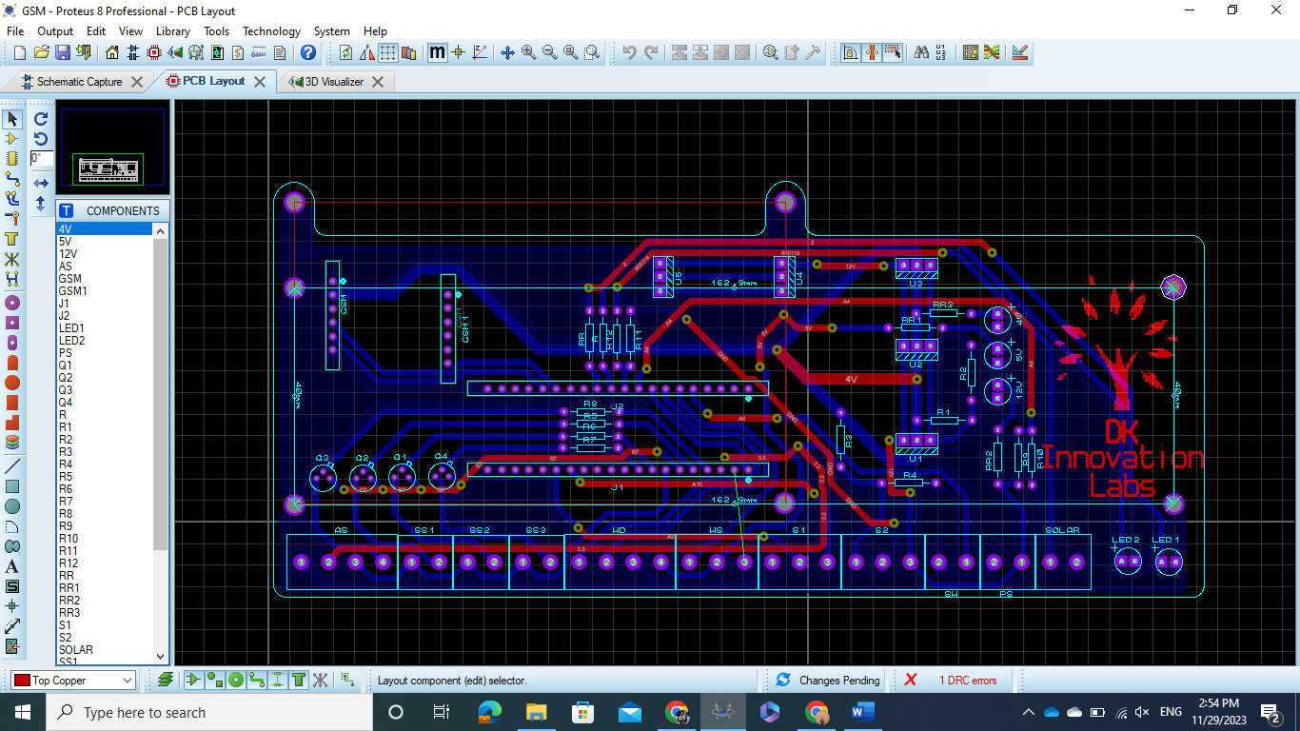

Figure 8 Main PCB

Figure 9 Charge Controller

In the main PCB there are 11 T-block terminals.

Figure 10 PCB Interface

**Terminal number 1**: - to Connect Air sensor, the air temprature and humidity sensor support I2C so it needs 4 pin(VCC, GND, SCK and SDA)

* Pin 1 -> GND
* Pin 2 -> VCC (3.3 Volt)
* Pin 3 -> SCK
* Pin 4 -> SDA

Note All Soil temprature and humidity sensors needs the same power source, so connect the VCC and GND cables in PIN 1 and 2 in the first terminal.

**Terminal 2,3 and 4** : - for Soil temprature and humidity sensor it needs 4 pin(VCC, GND, SCK and SDA), connect VCC and GND in terminal 1.

* Pin 1 -> SCK
* Pin 2 -> SDA

**Terminal number 5**: - Wind Direction

Under Progress, will be released in V2.0.

**Terminal number 6**: - Wind Speed

Under Progress, will be released in V2.0.

**Terminal number 7 and 8**: - NPK sensor

Terminal 7.

* Pin 1 -> GND for the signal converter.
* Pin 2 -> TX.
* Pin 3 -> RX.

Terminal 8.

* Pin 1 -> 3.3v for the signal converter.
* Pin 2 -> GND for the sensor.
* Pin 3 -> 12v for the sensor.

**Terminal number 9: -** Limit switch, No polarity

**Terminal number 10: -** Power Source (Battery)

* Pin 1 -> 12 Volt
* Pin 2 -> GND

Note: Terminal 9 and 8 are reversed, So double check pins order from picture number 10. Connect the battery cable in the last stage.

**Terminal number 11: -** Solar Panel volatge level monitor.

The solar panel has two +ve wire, and two GND. One pair for the power and the other for monitoring, in this terminal connect the low diameter pair.

* Pin 1 -> +ve pole.
* Pin 2 -> -ve Pole.

In Charge Controller Pins.

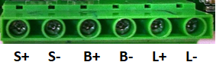

* Pin 1 -> Solar panel +ve Power calbe.
* Pin 2 -> Solar panel -ve Power calbe.
* Pin 3 -> Battery +ve Pole.
* Pin 4 -> Battery -ve Pole.
* Pin 5 -> Load +ve Pole (not used in V1.0).
* Pin 6 -> Load -ve Pole (not used in V1.0).

## 4.2 Step-by-step Mechanical Assembly

One-meter Aluminum Profile: -

* Attach the 8 L shape plates (90 degrees) to the ends of the aluminum profile. Four L shape plates go at the bottom ends, and four more are placed above the ends by 30 cm.
* 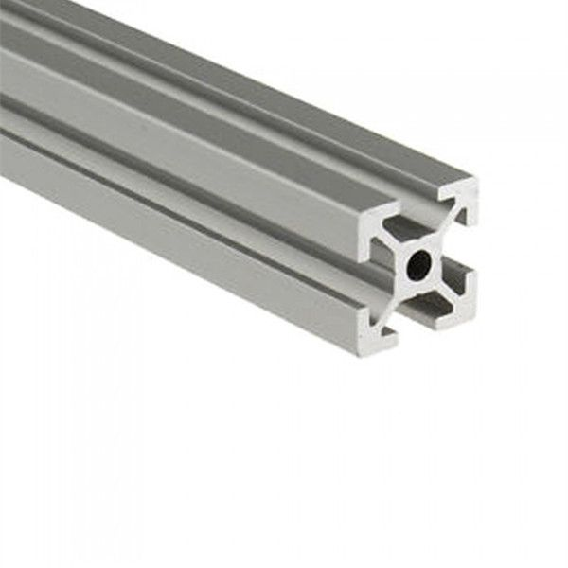

Figure 11 Aluminum profile

Note: - Ensure the plates are securely fastened to provide stability.

* Ground Placement, Insert the L shape plates into the ground, burying them at a sufficient depth for stability. Leave approximately 60 cm of the aluminum profile above the ground.

Mounting the Enclosure: -

* Attach two plates to the back face of the Enclosure. By two screw and Nylock style nuts. Figure number 12



Figure 12 Enclosure Plate

* Attaching the Enclosure to aluminum profile, Secure the enclosure to the Aluminum profile by T-nuts, aligning the enclosure as desired. Figure number 13

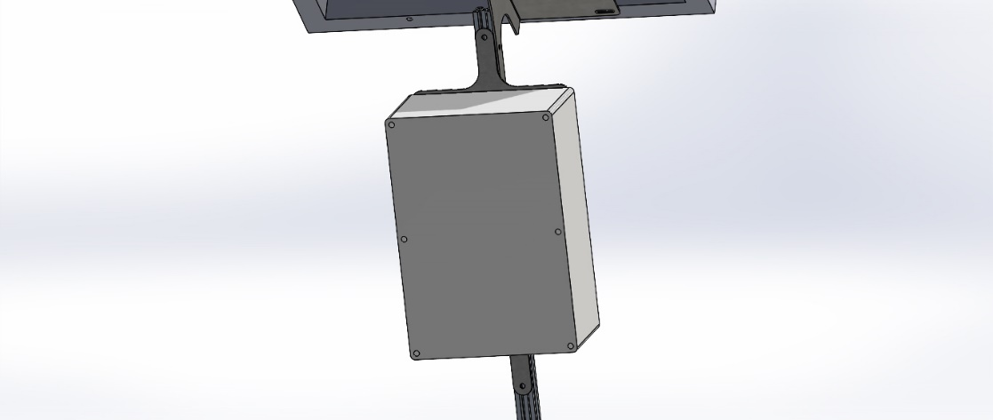



Figure 13 Enclosure fixed to Al profile.

Attaching the Solar Panel: -

Installing Plates for Solar Panel:

* Attach two plates, one on the right and one on the left side of the aluminum profile, using T-nuts. These plates will be used to connect the solar panel to the aluminum profile by two screw and Nylock style nuts in each side.



Figure 14 Solar Panel Mounting

Note: - Ensure the solar panel is positioned for optimal sunlight exposure, in Egypt position the solar panel face to 5:30 clock if the 12:00 arrow is located to direct North. (southeast)

Final Adjustments and Checks

* Tightening Connections: - Double-check all connections, ensuring that L shape plates, 2D plates, and the solar panel plates are securely fastened with T-nuts.
* Ensuring Stability: - Confirm that the entire structure is stable and securely anchored in the ground.
* Verifying Alignment: -Check the alignment of the solar panel and enclosure to ensure they are facing the desired direction.

## 4.3 Completion and Testing

* Connect the internal components following the electrical assembly instructions.
* Power up the system by exposing the solar panel to sunlight or using an alternative power source.
* Monitor Data Output, verify that data from the sensors is being transmitted correctly through the GSM module to confirm that the system is successfully updating the Google Sheets API.

## 4.3 Debugging and Tracing

Figure 15 Powering light indicators

Each LED refers to power level, for example.

* If GSM is not working (no light pulses) check if the 4V indicator is on or not.
* If 12V indicator is off -> check battery voltage.

Figure 16 Charge controller Light indicators.

* If the LED in the Red square is off, check solar panel cable.
* If the LED in the Blue square is emitting yellow color the battery is fully charged, if red its charging if it pulses red color with high frequency check the battery cable.
* If the LED in the Yellow square is on you can connect a load to LOAD Terminal (will be used in V3.0).

# 5. Appendix

## 5.1 Schematics

Figure 17 PCB Schematic

## 5.2 Source Code

Access the source code repository at [GitHub Repository Link](https://github.com/OmarSaadany/Weather-Station). The code encompasses algorithms for data processing, communication protocols, and system control.

## 5.3 Contact Information

|  |  |  |
| --- | --- | --- |
| Omar El-Saadany. | Khalid Eyada. | Osama Kamal. |
| omar.saadany@dakahlia.net | khaled.eyada@dakahlia.net | osama.kamal@dakahlia.net |